EXPERIMENT 4

- Find the class average for the subject ‘Physics’
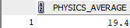
- Find the highest marks for mathematics (To be displayed as highest_marks_maths).
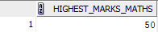
- Find the lowest marks for chemistry(To be displayed as lowest_mark_chemistry)
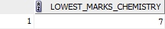
- Find the total number of students who have got a ‘pass’ in physics.
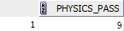
- Generate the list of students who have passed in all the subjects
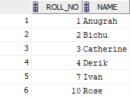
- Generate a rank list for the class. Indicate Pass/Fail. Ranking based on total marks obtained by the students.
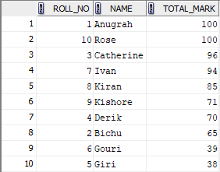
- Find pass percentage of the class for mathematics
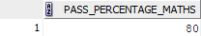
- Find the overall pass percentage for all classes.
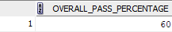
- Find the class average
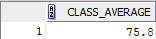
- Find the total number of students who have got a Pass.
